**JUSCO ORGANIZATION**

In a first of a kind initiative in India, the Jamshedpur Utilities and Services Company (JUSCO) was carved out of Tata Steel from its Town Services Division in 2004. In JUSCO, the steel major reposed nine decades of experience and expertise. The mandate for JUSCO was to convert an obligatory service into a customer focused sustainable corporate entity.

Jamshedpur Utilities & Services Company is today India’s only comprehensive urban infrastructure service provider. A Tata Enterprise, its services focus on the Tata Group Purpose “to improve the quality of life of the communities we serve”.

The Group purpose is reflected in JUSCO’s Mission of providing “quality services for life”. Its services include water, power, infrastructure, public health and horticulture services. JUSCO works alongside civic bodies, large and small industries, local government bodies, communities and individuals to deliver value through sustainable solutions.

The Company believes that a clear sense of the Tata Values and Mission allows it to achieve immense clarity on its role for the future. JUSCO intends to rise to the challenge of meeting India's need for infrastructure development in a sustainable manner by anticipating and addressing the country's growth needs such that the ability of future generations to meet their own needs is not compromised.

Jamshedpur Utilities and Services Company Ltd. (JUSCO) was born out of the vision and corporate philosophy of TATA Steel, which emphasizes a better quality of life for its stakeholders. The TATA Group has a glorious history of laying the foundation of many institutions and organizations that have grown to provide invaluable support to the socio-cultural development and sustenance of resurgent India. Tata’s culture of philanthropy has enriched India and its people in myriad ways.

 Jamshedpur Utilities and Services Company was borne out of the vision and corporate philosophy of Tata Steel, which emphasizes a better quality of life for its stakeholders. The Tata Group has a glorious history of laying the foundation of many institutions and organizations that have grown to provide invaluable support to the socio-cultural development and sustenance of resurgent India.  Tata’s culture of philanthropy has enriched India and its people in myriad ways.

In a first of a kind initiative in India, the Jamshedpur Utilities and Services Company (JUSCO) was carved out of TATA Steel from its Town Services Division in 2004. In JUSCO, the steel major reposed nine decades of experience and expertise. The mandate for JUSCO was to convert an obligatory service into a customer focused sustainable corporate entity. JUSCO today, is India’s only comprehensive urban infrastructure service provider. A TATA Enterprise, its services focus on the TATA Group Purpose to improve the quality of life of the communities we serve.

Further, JUSCO was conferred with 04 Awardsby the Public Relations Council of India (PRCI) at their 9th Global Communication Conclave held on 14 March 2015 at India Habitat Centre, New Delhi.

Public Relations Council of India (PRCI) is a national Registered Corporate Body, a Pan-India Organization of Public Relation Professionals, Corporate Communicators, advertising & media professionals and academicians. The PRCI Annual Corporate Collateral Awards are the most prestigious event in the realm of corporate communications presented annually to recognize talent and professional standards. The jury consisted of eminent professionals from the world of mass communication/ media. This year the PRCI received more than 750 nominations from 57 companies in 30 categories. Amongst prominent companies that participated and won the award were Coca-Cola, IDBI Bank, BEML, ITI, Jet Airways, Sahara India Pariwar, Mahindra & Mahindra, UB Group, MSPL, BIAL, Kingfisher, KMVIA, BHEL, Power Grid Corporation of India, Canara Bank, State Bank of Hyderabad, NTPC, Novartis, JUSCO, Tata Chemicals, FM Radio One, IMRB, KPCL, Central Bank of India and many others. The awards were conferred for Table Calendar, Diary (Small), House Journal (External Magazine) and Public Service Campaign (Zimmedaar Nagrik Zimmedaar Shaher).

Mr. A.P. Singh, DGM (Corporate Relations & Corporate Communications) and Ms. Sukanya Das, Corporate Communications received the Trophy and Certificates from Mr. Bhishma Narain Singh, Former Union Minister and Governor at the Annual Corporate Collateral Awards 2015 function at New Delhi.

**INTRODUCTION**

Information technology (IT) plays an important role in JUSCO operations and represents an essential component of the organization’s strategy to increase productivity and enhance mandated services for the benefit of citizens, businesses and employees.

Due to the growth in activities related to the nuclear sector, the company has recruited a number of highly skilled professionals in the scientific, technical and administrative fields. Over the past four years, in order to meet this expansion in the number of fulltime staff members, the company has made several investments in IT hardware and software.

Since these represent attractive and important assets, an independent examination of the accuracy and completeness of the inventory and records was proposed to management.

The Information Technology Department develops and implements an IT planning process that is integrated with the company’s overall corporate planning process and aligned with the investment planning process. The resulting plan defines company’s IT directions, strategies, architecture and human resource capacity, and how these work together to achieve company business and government-wide strategic objectives. The IT Plan reflects company priorities and outlines planned investments, including any acquired services. The company’s IT Plan is reviewed annually, and updated as required.

Although common or shared IT assets and services are used as much as possible at the company, as a way to avoid duplication, such assets and services are available and appropriate. This strategy is aligned with the company’s IT management practices, processes and technology architecture.

IT assets and services are reviewed periodically, to identify opportunities for enhancing efficiency, effectiveness and innovation in collaboration with service providers, service users and other stakeholders.

Traditionally, IT Asset Management (ITAM) systems have seldom lived up to their potential. This has not stopped organizations from pursuing the dream of having a centralized system to house all the data and provide functionality to support the entire IT asset lifecycle. There is simply too much to gain by controlling inventory, avoiding massive unplanned expenses, increasing productivity and having easy access to information to make strategic decisions.

When done properly, ITAM can also reward organizations with stronger vendor discounts that have a direct impact in lowering both hardware and software spend. Having better control of the IT asset lifecycle also helps drive standards into organizations, which will improve efficiency and reliability.

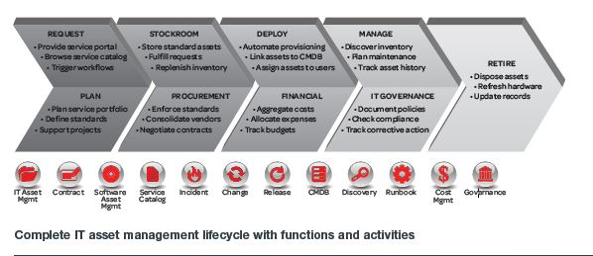

Fig.1 Complete IT Asset Management Lifecycle with Functions and Activities

The reason ITAM systems rarely deliver on their potential is not a functional one – most solutions offer more bells and whistles than many organizations would care to deploy. The main reason for not delivering success can be blamed on the difficulties of integrating them into the overall IT ecosystem.

For one, they are typically a collection of many disjointed asset applications often with incompatible technologies. Secondly, they often rely on canned adaptors and bulk loaders that limit the number of touch points they can access. Lastly, and most important, the workflow components included in these systems do not tie into other workflow systems used by IT. This effectively limits the possibilities of process automation to just a handful of simple use cases. Organizations cannot advance in maturity due to the inability to tie together processes that cross multiple disciplines.

This is the exact challenge IT faces when trying to figure out what to do with all of the outdated service management systems scattered throughout the enterprise. We have tried to incorporate in our project an ITAM solution that allows organizations to consolidate legacy ITAM systems and fully automate the ITAM lifecycle.

**OBJECTIVES**

Dealing with enormous amount of information has become an integral part of complex systems across all sectors. The concept of efficient management of data when extended to the personal level can go a very long way in saving an individual’s time.

The goal of this project is to:

• Ensure that IT assets meet inventory needs as well as operational requirements.

• Ensure value for money in IT assets.

• Ensure that procurement activities stand the test of auditor’s scrutiny in matters of prudence and integrity, encourage competition, and reflect fairness in spending of company’s funds.

• Maintain a database system and link with other modules.

• Introduce modern technology to obtain information from other departments.

• Availability of relevant, selected information to the users

* Ensure the obedience of the company’s policies throughout the project making.
* Ensure accounting of assets and it’s usage to it’s optimum potential

Through this project we try to answer the following questions,

* What are the management issues and challenges we see at large multinationals?
* What is an asset management capability?
  + What are the best practices?
  + What benefits have been achieved through improved asset management capabilities?
* What steps do companies take to implement improved asset management capabilities?

**Key Performance Indicators**

A Key Performance Indicator (KPI) is a measurable value that demonstrates how effectively a company is achieving key business objectives. Organizations use KPIs to evaluate their success at reaching targets. Some of the performance measured criteria’s are stated as follows,

* + Asset information
  + Stakeholders
  + Condition and performance
  + Operational/maintenance
  + Service quality
  + Financial

**Key Factors**

* System performance (capacity, remaining service life, condition)
* Serviceability Impact (disruptions in daily life)
* Risk tolerance level (health, safety and other direct and indirect costs)
* Long-term impact (environmental and other intangible impacts)
* Operation and Maintenance cost (life cycle basis)

**LITERATURE REVIEW**

**Poor asset management processes will lead to high costs in the business**

* Extra Capacity -- especially in distributed computing
  + Extra desktops: hardware and software
  + Excess network bandwidth
  + Server capacity
* Increased fixed costs reduce financial flexibility
  + Long Contract Terms -- especially in dynamic services areas, e.g., telecommunication, desktop services
* Insufficient consideration of “total cost of ownership”
  + Upfront hardware costs are usually key priority
  + More attention should be given to standards and reduction of ongoing support costs
  + Decide the right level of maintenance service required to support the business

**Finally, poor asset management can impact an organization’s ability to respond effectively to business requirements**

* “Just-in-time” Justification: Infrastructure and assets often justified on a project by project basis
  + Affects the economics of the project
  + Slows down the process of acquiring new equipment to meet a business need
  + May lead to the lowest-priced hardware solution, even if it is non-standard
* Planning: Often reactive following ad hoc, last minute capacity and functionality requirements to deliver new solutions.

**METHODOLOGY**

ITAM business practices are process-driven and matured through iterative and focused improvements. Most successful ITAM programs are invasive to the organization, involving everyone at some level, such as end users (educating on compliance), budget managers (redeployment as a choice), IT service departments (providing information on warranties), and finance (invoice reconciliation, updates for fixed asset inventories)

IT asset management generally uses automation to manage the discovery of assets, so inventory can be compared to ownership information. Full business management of IT assets requires a repository of multiple types of information about the asset, as well as integration with other systems such as [supply chain](https://en.wikipedia.org/wiki/Supply_chain), [help desk](https://en.wikipedia.org/wiki/Help_desk), [procurement](https://en.wikipedia.org/wiki/Procurement) and HR systems and ITSM.

Best practices for each of the asset management processes provide guidelines for building new capabilities

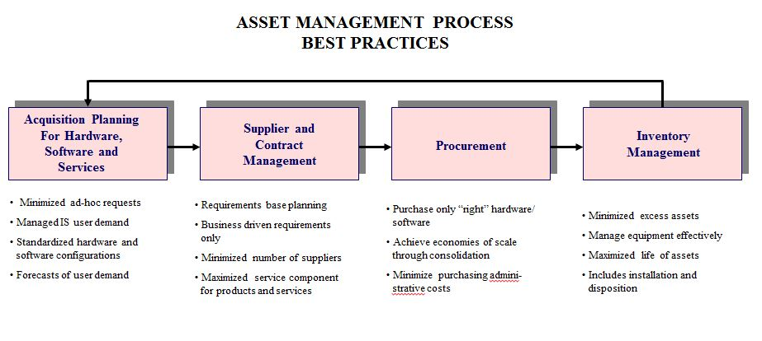

Fig.2 A minimalistic view of best practices processed under asset management.

These best practices are used to identify gaps in current capabilities.



Table 1. Examples of capability gaps.

**Prototyping**

Prototyping is the activity of creating [prototypes](https://en.wikipedia.org/wiki/Prototype) of software applications, i.e., incomplete versions of the [software program](https://en.wikipedia.org/wiki/Software) being developed. It is an activity that can occur in [software development](https://en.wikipedia.org/wiki/Software_development_process) .A prototype typically simulates only a few aspects of, and may be completely different from, the final product.

Prototyping has several benefits: The software designer and implementer can get valuable feedback from the users early in the project. The client and the contractor can compare if the software made matches the [software specification](https://en.wikipedia.org/wiki/Program_specification), according to which the software program is built. It also allows the software engineer some insight into the accuracy of initial project estimates and whether the deadlines and [milestones](https://en.wikipedia.org/wiki/Milestone) proposed can be successfully met. The degree of completeness and the techniques used in the prototyping have been in development and debate since its proposal in the early 1970s.

**Snapshots Of The Project While Development:**

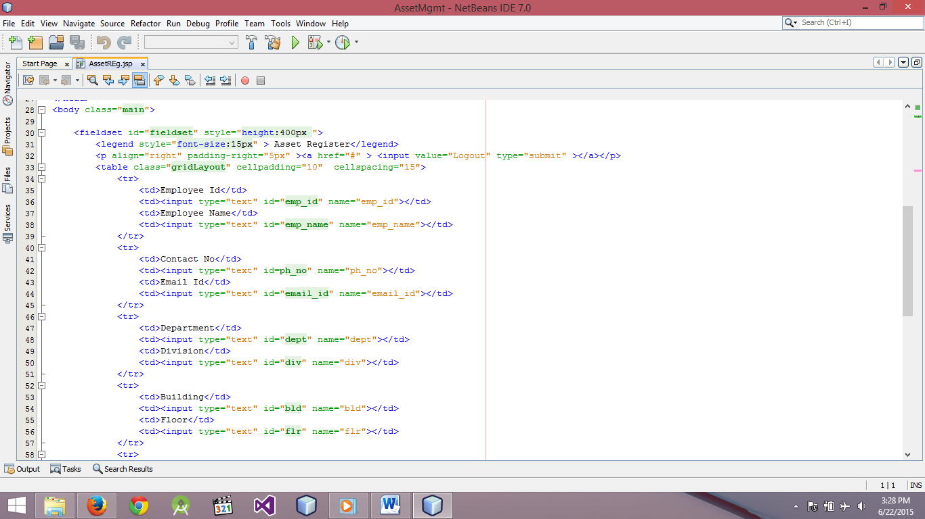

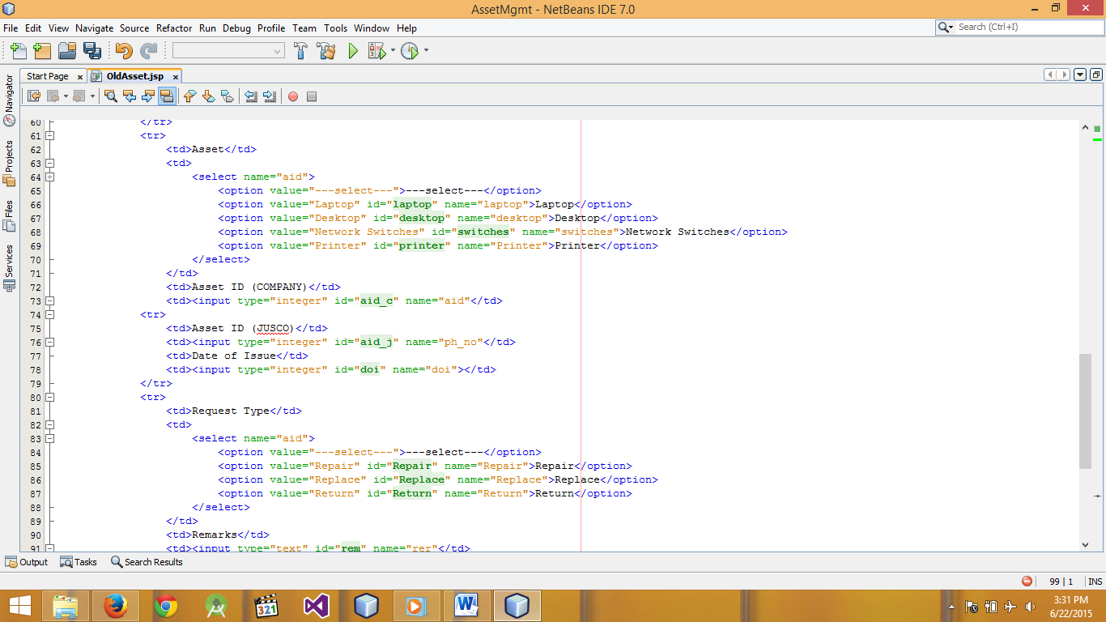Fig.3 Asset Register Coding

Fig.4 Old Asset Coding

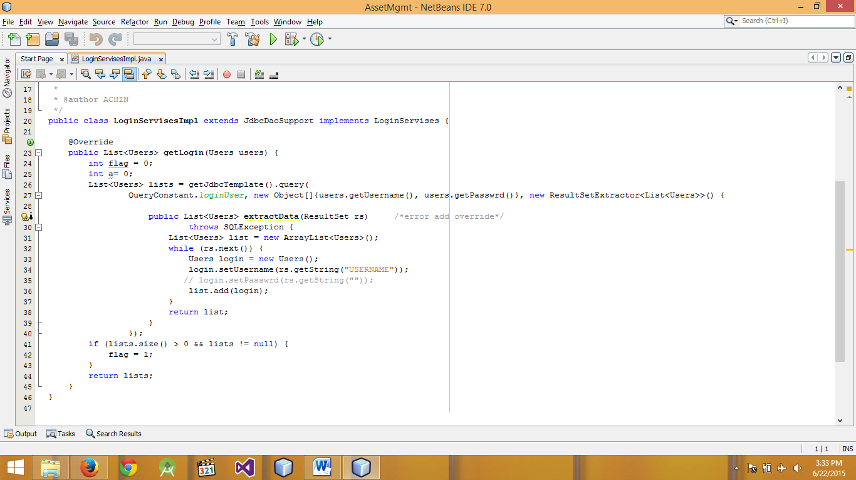

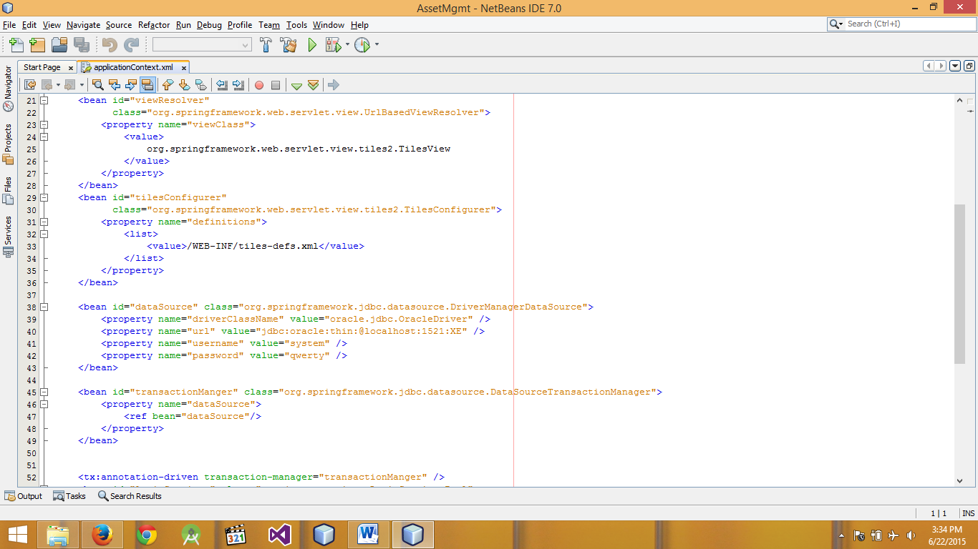Fig.5 Login Services Coding

Fig.6 Application Context Coding

**Software Requirements Specification**

**1. Introduction**

The Software Requirements Specification (SRS) provides an overview of the entire SRS with purpose, scope, definitions, acronyms, abbreviations, references and overview of the SRS. This is a SRS document for Asset Management Software. The objective of Asset Management Software is to provide complete details of Asset and its Employee and provide additional options for asset that can be used by employee and the organization in action.

## 1.1 Document Purpose

The purpose of this document is to describe the requirements for the Asset Management Software. The intended audience includes all stakeholders, Employee and Administration in an organization. These include, but are not necessarily limited Developers should consult this document and its revisions as the only source of requirements for the project. They should not consider any requirements statements, written or verbal as valid until they appear in this document or its revision.

## 1.2 Product Scope

The proposed software product is the Asset Management Software. The system will be used to get the information from the Employee and then storing that data for future usage. The current system in use is a paper-based system. It is too slow and cannot provide updated lists of assets within a reasonable timeframe. The intentions of the system are to reduce over-time pay, decrease manual labor and increase the number of assets that can be treated accurately. Requirements statements in this document are both functional and non-functional.

1.3 Intended Audience and Document Overview

The intended audience includes all stakeholders in the potential system. These include, but are not necessarily limited to, the following: Administrative Staff, Employee and developers. The objective of this document therefore is to formally describe the system’s high level requirements including functional requirements, non-functional requirements and business rules and constraints. This model demonstrates the development team's understanding of business domain and serves to maximize the team's ability to build a system that truly does support the business.

## 1.4 Definitions, Acronyms and Abbreviations

* AssetRegister **–** a record to maintain the asset details.
* Asset Request Form **–** a record to request asset from authority or superior.
* Login ID- a user identification number to enter the system
* Password- a word that enables one to gain admission into the system
* Web-based application- an application that runs on the Internet
* SQL– structural query language
* GUI- Graphical User Interface
* SRS **-** Software Requirements Specification
* DBMS-Database Management System, a database to store all involved information

**2. Overall Description**

2.1 Product Perspective

This Asset Management Software is a self-contained system that manages activities of the Asset as Asset Register Info. Various stakeholders are involved in the Asset Management Software. This product will help the Employee to request their asset needs with ease and no complication of waiting in queues for requesting Asset. It will employ two modes of communication such as Asset Register, Asset request form.

## 2.2 Product Functionality

The system functions can be described as follows:

* Asset Register**:**

When an Administrator has to add details of an asset in asset register, he is intended to add the unique details of the Employee whose data is being fed, into the asset register(say, Employee ID). After adding the Employee Id, the server fetches data from database of the employee administrator, matches the data and adds the request of Employee to the register.

* Asset request Form:

When an Employee has to make a request for asset he selects the asset request form option. Before proceeding further, he has to select whether the request is for old device or new device. After selecting the device type he has to provide his ID for proceeding further. As he provides the employee id the server fetches the details of employee and automatically fills the space allotted for it. After this he has to add his superior contact number to whom he his making request. From this information, server fetches the mail ID of superior and automatically fills the space for it this mail id will be used to send the request to superior. Further, the Employee is supposed to select the asset and submit his request. Then these details are automatically forwarded to the specified superior mail id.

* Policy:

The Administrator or organization can add rules and regulations foe asset in policy section which will help Employee for easy request.

## 2.3 Users and Characteristics

The system will be used in the organization. The administrators and Employee will be the main users. Given that not all the users are computer-literate, the system is designed to be user-friendly. It uses a Graphical User Interface (GUI).

Administrators:

They have the authority to access the database, server and are responsible for adding request to the asset register.

Employee:

The Employee will adding request for asset and for replace, return and repair like additional options.

## 2.4 Operating Environment

The Asset Management Software requires at least a Windows XP or higher version to run on any laptop. The system works properly on various browsing platforms such as Mozilla Firefox, Google Chrome, or even Internet Explorer. The application is only accessible within the organizational server or Network Connection. It is restricted to use this service within an organization.

## 2.5 Design and Implementation Constraints

* All of Asset Register and Asset request form record must be protected for all steps.
* In the future, it is possible that the software design will have to incorporate changes that could take place in other Organization in the same domain. The Asset Register and Asset request form record of all organizations in domain should have the same standard of data format and security of data when transferring between the organizations also needed.
* Changes or additions about Entering methods can affect the system directly.
* The system must be user-friendly.

## 2.7 Assumptions and Dependencies

* It is assumed that hundred computers will be available before the system is installed and tested.
* It is assumed that the organization will have enough trained staff to take care of the system
* The system uses licensed third party software products.

#### 3. Specific Requirements

## 3.1 External Interface Requirements

* User Interfaces -The user interface for software shall be compatible to user which can access to the system. The user interface shall be implemented using any tool or software package like servlet, Html5, jsp, css3, etc.
* Hardware Interfaces- We would need the Intel Celeron system and 1 GB of RAM and a Minimum Space of 1Gb space in Server to work smoothly.
* Network Interfaces- The server and client computer must have NIC card and must get the intranet service active from well-known ISP.
* Software Interfaces- The client machines require Microsoft Windows XP or better. The corporate server requires Red Hat Enterprise Linux AS 5 (RHEL 5) and Oracle Database 10g Enterprise Edition to hold on to all archives. The client requires Net Beans 7 or higher and virtual server. Also both the client and server computer must have internet browser to work online.
* Communications Interfaces- The System will perform the following functions:
* Sophisticated and user friendly interface for all passengers.
* Individual record for each user related to the system.
* Sophisticated interfaces for all people who related to the system.
* Implement Administrator and Employee database systems. Implement Account System for managing invoices.
* Each Employee need only an Employee Id for walking through every step.
* Keep secret for all of Employee Record. Each division can see only necessary data of each Employee for analyzing.
* Internet connection to work on with the system.
* Real time or dynamic service should be given in case of all changes appearing in the system.

## 3.2 Functional Requirements

## Asset Management Software:

* Username:This requires the username of administrator while logging in the system.
* Password:This requires the password from administrator while logging in the system.
* Employee Id**:** This requires the unique id form employee given by the organization to the employee.
* Employee Name**:** This requires the employee name working or requesting in an organization.
* Contact Number: This requires the contact number of employee that he has registered within the organization.
* Email Id: This requires the email id of employee that he has registered within the organization.
* Department: This requires the department of employee under which the employee is currently working.
* Division: This requires the division within a department under which the employee is currently working.
* Building: This requires the accurate place where the employee is working , for more specifically the building where he is working.
* Floor: This requires the accurate place where the employee is working , for more specifically the floor where he is working.
* Asset Required:This requires the type of device requested by the employee like desktop, laptop, printers, etc.
* Asset Id:
* Company Id:This requiresthe id of the asset that has provided by the company at the starting of product creation.
* Organizational Id:This requiresthe id of the asset that has provided by the Organization at the starting of product allocation.
* Date of Issue:This requires the date when the asset is allotted to the employee.
* Repair:This defines the option of repairing any previous device by employee.
* Replace: This defines the option of replacing any previous device by employee.
* Return: This defines the option of returning any previous device by employee.
* Superior Employee Id:This requires the unique id of superior to which the request of asset is going to send by employee.
* Superior Mail Id:This requires the mail id of superior to which the request of asset will be mailed.

#### 4. Other Non-Functional Requirements.

4.1 Performance Requirements

* Response Time:The system shall give responses in 1 second after checking the Employee information.
* Capacity:The System must support 1000 people at a time.
* User-interface: The user-interface screen shall respond within 5 seconds
* Conformity: The systems must conform to the Microsoft Accessibility guidelines.
* Network Connection: They should be connected to internet 24 X 7. And the Server must be on all time.

## 4.2 Safety and Security Requirements

## 

* Employee Identification:The system requires the Employee to identify himself using Employee Id.
* Login ID: Any user who uses the system shall have a Login ID and Password.
* Modification: Any modification (insert, delete, and update) for the Database shall be synchronized and done only by the administrator in the Organization.
* Administrators' Rights: Administrators shall be able to view and modify all information in DBMS.

.

## 4.3 Software Quality Attributes

#### Maintainability:

* Back Up: The system shall provide the capability to back-up the Data
* Errors: The system shall keep a log of all the errors.
* Reliability:The portal will be reliable with the ease of Requesting and security
* Availability: The system shall be available all the time

**SOFTWARE AND HARDWARE REQUIREMENTS**

The Asset Management System deals with the basic problem of managing enormous data. It caters to the organization of data in a well-structured form facilitating its maintenance and expansion.

It makes us of JAVA programming language to process the data and MySQL database management system for storing the data. This system uses a web browser for user interaction and provides the user the facility to add, modify and view asset information.

The JavaServer Pages(JSP) are used for collecting, modifying and displaying information to the user. The system also incorporates user authentication leading to better data security.

**Software Requirements**

1. **Net Beans IDE**

Net Beans is an open source Integrated Development Environment (IDE) used extensively for web-application development.

This would be used for processing the information received via JavaServer Pages. It is also used for interacting with the database, in this case MySQL, for storing, modifying and retrieving information.

1. **Apache Tomcat**

Apache tomcat is an open source web server and servlet container. Tomcat implements the Java Servlet and the Java Server Pages specification from Oracle Corporation, and provides a pure Java HTTP web server environment for a Java code to run. This would be used to host the JavaServer Pages required for user interaction.

1. **MySQL**

MySQL is an open source database management system. In this asset management system, MySQL is used for organizing the user information. The MySQL Workbench is used for creating and executing SQL queries. It also helps in designing and managing the database more efficiently.

It provides a console to gain better visibility into a database. Any further expansion or manipulation to the existing data structure can be achieved expeditiously using MySQL workbench.

1. **Web Browser**

A web browser is a software application for retrieving and presenting information on the World Wide Web. This system is hosted using the Apache Tomcat web server and can be accessed via a web browser by entering the URL of the hosted JavaServer Page. All the user-system interactions are done through the web browser.

**Hardware Requirements**

1. An Intel (or equivalent) Pentium 300MHZ processor
2. 1GB memory is the minimum amount we should consider for storing the database
3. HDD-500GB minimum
4. Windows OS is preferable (Windows XP being the minimum compatible software)

**MODULE DESIGN**

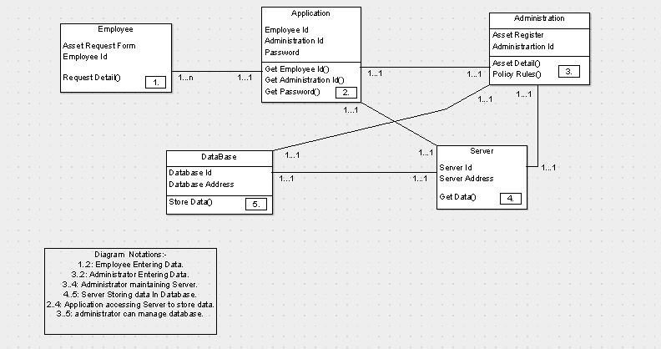

Fig.7 Class Diagram of Asset Management System

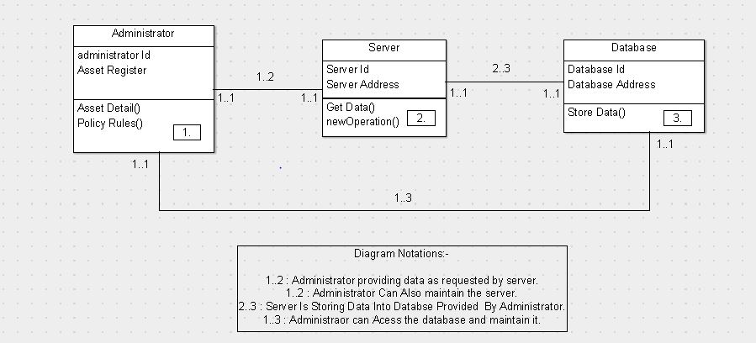

Fig.8 Class Diagram of Asset Register

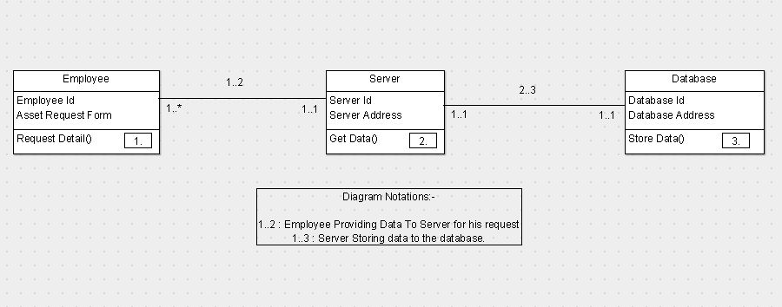

Fig.9 Class Diagram of Request Form

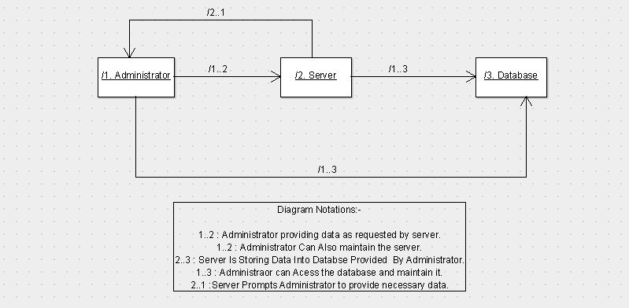

Fig.10 Collaboration Diagram of Asset Register Process

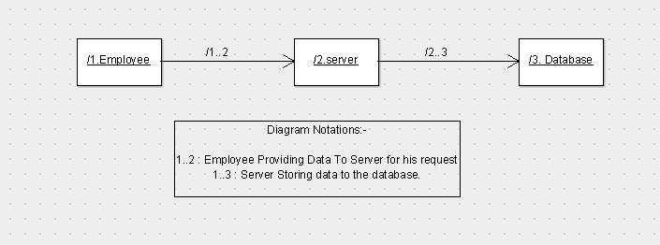

Fig.11 Collaboration Diagram of Asset Request Procedure

**CODING**

package com.jusco.controller;

import com.jusco.model.Users;

import com.jusco.servises.LoginServises;

import com.jusco.servises.LoginServisesImpl;

import java.util.List;

import javax.servlet.http.HttpServletRequest;

import javax.servlet.http.HttpServletResponse;

import javax.servlet.http.HttpSession;

import org.springframework.beans.factory.annotation.Autowired;

import org.springframework.jdbc.core.JdbcTemplate;

import org.springframework.stereotype.Controller;

import org.springframework.ui.ModelMap;

import org.springframework.web.bind.annotation.ModelAttribute;

import org.springframework.web.bind.annotation.RequestMapping;

import org.springframework.web.bind.annotation.RequestMethod;

@Controller

public class LoginCotroller {

@Autowired

private LoginServises login;

JdbcTemplate jdbc = new JdbcTemplate();

@RequestMapping(value = "/Login", method = RequestMethod.GET)

public String loginServices(ModelMap map, HttpSession session, HttpServletRequest request, HttpServletResponse response) {

System.out.println("=======================Login=================");

return "Login";

}

@RequestMapping(value = "/Login", method = RequestMethod.POST)

public String loginServices1(ModelMap map, @ModelAttribute("loginPage") Users loginPage, HttpSession session, HttpServletRequest request, HttpServletResponse response)

{

// System.out.println("=======================Success=================");

//System.out.println(loginPage.getUsername());

// System.out.println(loginPage.getPasswrd());

List<Users> list = login.getLogin(loginPage);

int a = loginPage.getA();

if (list.size() > 0) {

String userid = list.get(0).getUsername();

session.setAttribute("userid", userid);

if (a == 1) {

return "AssetREg";

}

else if (a == 2) {

return "AssetTrf";

}

else {

session.removeAttribute("userid");

map.addAttribute("result", "Invalid Request.");

map.addAttribute("username", loginPage.getUsername());

return "Login";

}

}

else {

map.addAttribute("result", "Invalid password or username.!!");

map.addAttribute("username", loginPage.getUsername());

return "Login";

}

}

@RequestMapping(value = "/home", method = RequestMethod.GET)

public String getHome() {

return "Home";

}

}

public class AssetReg {

@RequestMapping(value = "/AssetREg", method = RequestMethod.GET)

public String getAssetREg(ModelMap map, HttpSession session, HttpServletRequest request) {

String userid = (String) session.getAttribute("userid");

if (userid == null) {

int a = Integer.parseInt(request.getParameter("a"));

System.out.println("A =" + a);

map.addAttribute("aval", a + "");

return "Login";

}

return "AssetREg";

}

@RequestMapping(value = "/AssetREg", method = RequestMethod.POST)

public String postAssetREg() {

return "AssetREg";

}

}@Controller

public class AssetTrf {

@RequestMapping(value = "/AssetTrf", method = RequestMethod.GET)

public String getAssetREg(ModelMap map, HttpSession session, HttpServletRequest request) {

String userid = (String) session.getAttribute("userid");

if (userid == null) {

int a = Integer.parseInt(request.getParameter("a"));

System.out.println("A =" + a);

map.addAttribute("aval", a + "");

return "Login";

}

return "AssetTrf";

}

@RequestMapping(value = "/AssetTrf", method = RequestMethod.POST)

public String postAssetTrf() {

return "AssetTrf";

}

}…….

**SNAPSHOTS**

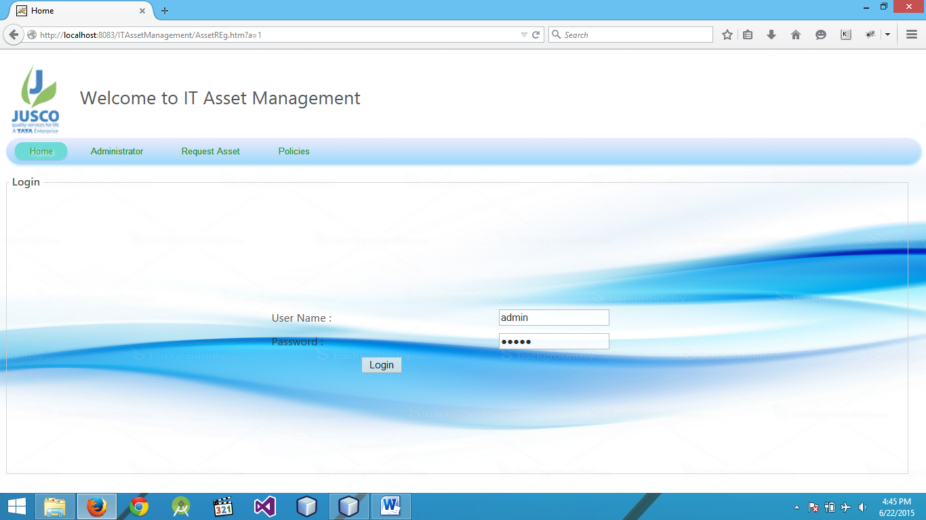

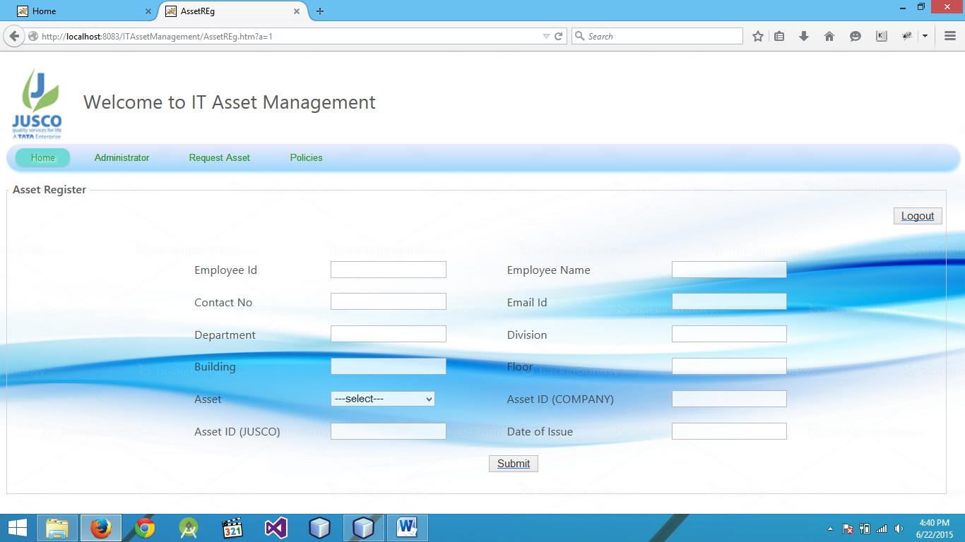Fig. 12 Login Page for Administrator

Fig. 13 Asset Registration Form for the Administrator

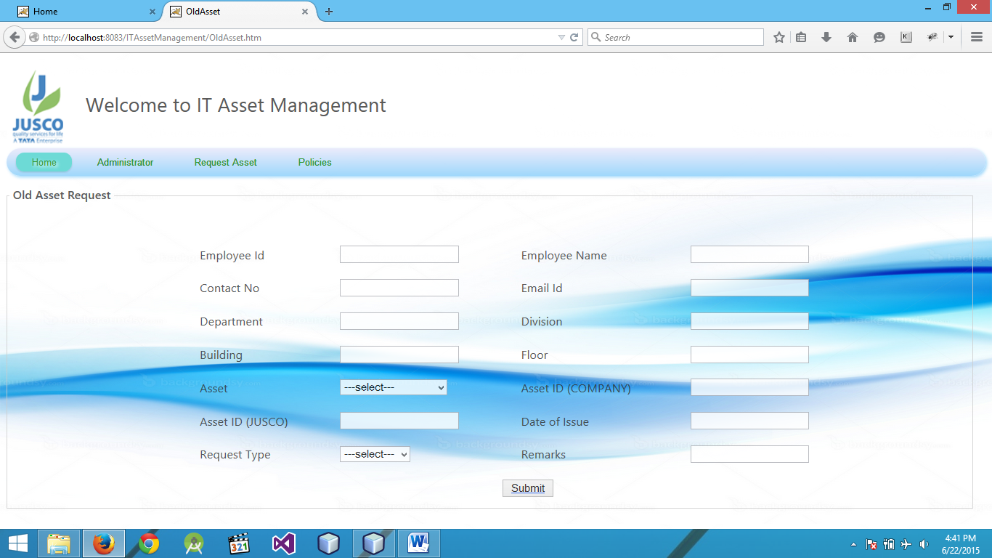

Fig. 14 Old Asset Request Form for the User

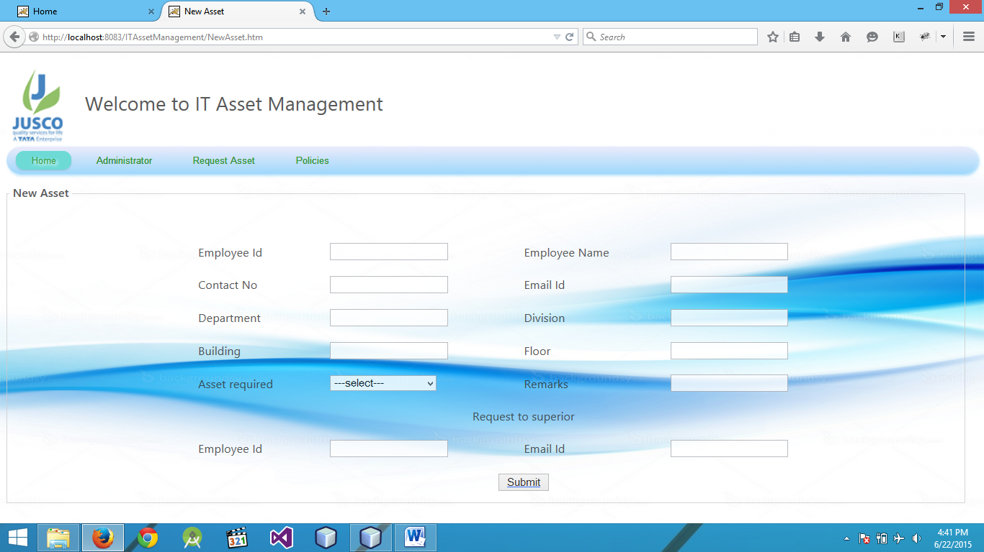

Fig. 15 New Asset Request Form for the User

**APPLICATIONS**

* **Integrated Workplace Management**

Effectively measuring corporate and commercial real estate performance requires a single repository of portfolio planning, projects, leasing, space allocation, and tenant services and facilities management information.

* **Lean Maintenance and Quality Compliance**

Overcapacity and low-cost competition press manufacturers to eliminate waste at every turn; but lean maintenance is hindered by the lack of standardized best practices and performance reporting. Multiple silos of information also lead to overstocking.

* **Lifecycle Management**

Monitoring and effectively controlling capital asset performance from specification and procurement, through construction, commissioning, and maintenance, to retirement is an elusive goal for governments and infrastructure companies.

* **Collaborating needs and efficient deployment**

Maintenance of asset requirement records and requirement specifications of employees makes it an easy task for the IT department to provide asset accordingly to the officers.

* **Handling manual works**

Direct handling of the request or asset management and maintenance request through e-mail forwarding to higher authorities escapes manual work as well as natural delays as everything is handled by e-commerce.

**ADVANTAGES & DISADVANTAGES**

**ADVANTAGES:**

**Asset Management Provides the Foundation to Optimize the Resources of the Business**

* Control over the infrastructure provides the ability to plan ahead
  + Capacity -- How many assets are installed? How many more do we need?
  + Ownership -- Where are the assets located? Can we cascade to reduce excess capacity?
  + Capability -- What assets will be required to support the critical business applications?
* Asset management standards minimize complexity in the infrastructure
  + Higher service levels due to a controlled number of software packages and hardware configurations
  + Reduced inventory of non-standard equipment
* Expertise can be focused on high priority business objectives rather than supporting non-standard applications and configurations

The above stated points prove to be the advantages of bringing in the concept of Asset Management into the organization.

**DISADVANTAGES:**

* Impacts for uncertainties like condition, performance and economic factors
* Misleads when an old asset behaves like good condition as new asset
* Difficult to predict future cost and asset usage
* Traditional design-build- operate-maintain approach is simply inadequate in the face of current dilemma

**CONCLUSION**

The asset management system is designed for efficient management of several assets possessed by an individual. It allows the user to add information about different as-sets in a quicker and systematic way. The data is organized efficiently to aid future expansion of the system.

The user is facilitated with the feature of updating the existing information of an asset entry. This feature is especially helpful while maintaining assets, since their values are constantly changing.

The asset management system provides the facility to view the different asset entries pertaining to different asset types. This feature helps to keep a track of all assets in a much quicker and efficient way as compared to the traditional method of poring over innumerable files.

**FUTURE SCOPE**

Since, the system is organized in a very structured manner using MySQL database, it is possible to expand the system to encompass even more information. More number of attributes regarding an asset can be stored, modified and viewed depending upon the requirement.

The number of possible operations on the data can be increased. Features like sorting asset entries based on their value, last modified date can be incorporated.

Computational features such as calculating the current value of assets, calculating the increase or decrease in the value of an asset can also be integrated with the existing system.

A feature to create soft-copying different file formats like .xls, .pdf, .doc of different assets possessed by a user can also be unified in the system. This feature would help the user to instantly process an electronic copy of the list of assets currently maintained in the system.

Software asset management (SAM) is an important part of the ITAM solution that includes many innovative and compelling features to help organizations reach higher levels of process maturity

**REFERENCES**

1. Bonneville Power Administration DOE/BP-3690 z January 2006
2. International Journal of Scientific & Engineering Research, Volume 3, Issue 10 October-2012
3. Budi Kurniawan, Java for the Web with Servlets, JSP, and EJB: A Developer's Guide to J2EE Solutions.
4. Wikipedia, The Encyclopedia
5. Government of North-West Territories Municipal and Community Affairs-Asset Management Presentation_2007